Professor and Head of Rheumatology, Physical Medicine and Rehabilitation Department, Benha Faculty of Medicine, Benha University since Dec 6th 2021 till now.
Board Member of the Supreme Council for promotion of Professors and Associate Professors of Rheumatology, Physical Medicine and Rehabilitation since Sep. 2022 till now.
Board Member of the Egyptian Society for Rheumatology and Rehabilitation 2013- 2022.
Board Member of Scientific Ethical Committee Benha Faculty of Medicine, Benha University 2012-2013.
Editor In Chief of Egyptian Rheumatology and Rehabilitation Journal.

H-index: 5 Ganeb, Sahar Saad
ORCID: https://orcid.org/0000-0002-5932-374X
Research Gate: Sahar Ganeb

1
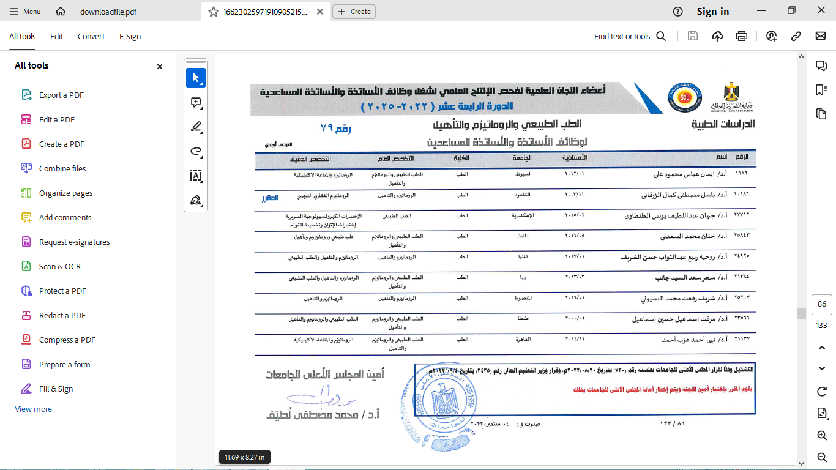
2
